KUNTAL ACHERJEE

E-mail:
kuntalacherjee@gmail.com

Mobile: (+91) 9038380210

Address for Communication:

96,Swami Vivekananda road,
Birati
Kolkata – 700 051

Personal Information:

Father's Name: Chinmoy Acherjee
Date of Birth: 25.11.1991
Nationality: Indian
Gender: Male
Religion: Hindu
Linguistic Proficiency: English,Bengali,Hindi

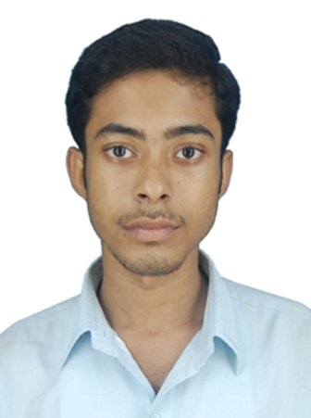

Career Profile:
To have a successful career and take challenges in life to achieve the goal through constant learning, self-development and sincerity.
PERSONAL BEHAVIORAL SKILLS

- Pragmatic and problem solving approach
- Ability to achieve results
- Traits of a good coordinator
- Hard Working and Self-Motivated
- Ability to work under pressure and stress
CORE COMPENTENCIES

- Power System
- Basic Electrical

INDUSTRIAL EXPOSURE

I. INDIAN RAILWAY -
PLACE – Eastern railway (Sealdah Branch)

DURATION -01.06.2011-15.06.2011

PROJECT TITLE-

    - Railway traction system,
    - Power supply to the railway traction
    - Train lighting

ii. WBSETCL (132kV, 400 kV)
PLACE- Kalyani substation & Arambag substation
DURATION- 26.12.2011-07.01.2012 (Kalyani)
11.06.2012-23.06.2012 (Arambag)
PROJECT TITLE-
    - Transmission line,
    - Protective device, effects
    - Substation equipments.

ACADEMIC QUALIFICATION

Course | University / Board | Year of Passing | Percentage/CGPA
B.Tech | WBUT | 2013 | 8.44
Higher Secondary (10+2) | WBCHSE | 2009 | 75.4%
Secondary (10th) | WBBSE | 2007 | 84.62%

COMPUTER PROFICIENCY

Content : MS-Office (Word, PowerPoint), Internet, language programming-C

DECLARATION: I hereby certify that all the details furnished above are true to the best of my
Knowledge and awareness.

Date:

Place: Kolkata KUNTAL ACHERJEE

